USER GUIDE

for the

Web-based Course Registration System

USER GUIDE

for the
Web-based course registration system

Contract No
16

Prepared For:
International College
University of Science and Technology, Yemen

Prepared By:
Asem Mohammed Abdulaziz Farhan

Authenticate by __________________ Approved by __________________
(Contracting agency) (Contractor)

Date __________________________ Date _______________________

1 INTRODUCTION

1.1 Identification

System Number : IC-Y2010-S07-C16
System Name : Web-based course registration system
System Abbreviation : W_CRS

Overview of the Documents

This document is used for guiding the user for how to install Web-based Course Registration System properly.

LIST OF FIGURE (S)
Figure 1: Login page
Figure 2: Main interface
Figure 3: Set course registration period
Figure 4: Set course registration period
Figure 5: Course Registration
Figure 6: Course Registration (2)
Figure 7: Register courses for special cases
Figure 8: Courses information
Figure 9: Create user
Figure 10: Search Student
Figure 11: Change password
Figure 12: Generate report
Figure 13: Generate report (2)
Figure 14: Generate report (3)
Figure 15: Manage Marks
Figure 16: Manage Marks (2)
Figure 17: Manage Course
Figure 18: Manage Course (2)

USER GUIDE

- Login
- Enter a valid username and password then press on the <Login> button.
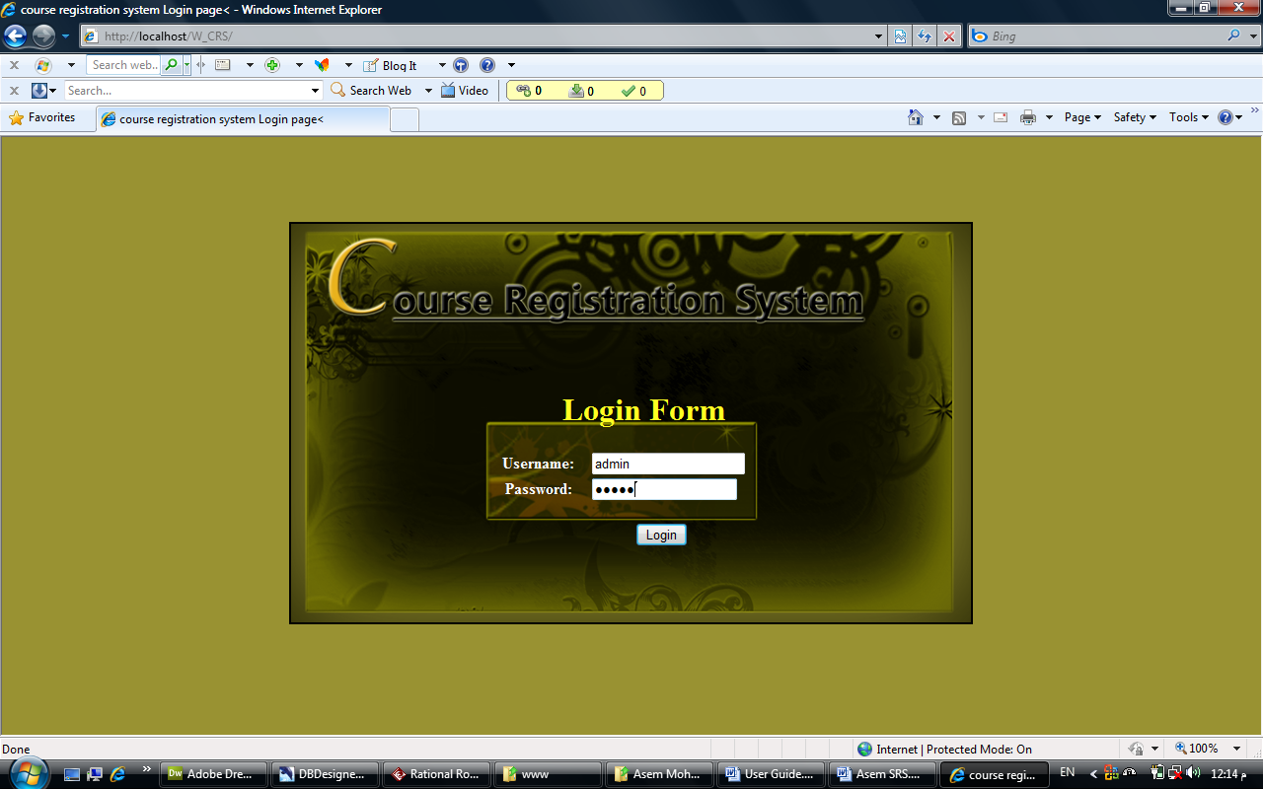

Figure 6: Login page

- The option that will display to the user after He/She login depends on the type and the roles of the user as described in following:

Administrator Registrar Student
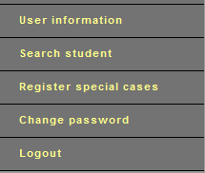
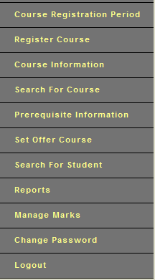
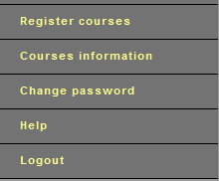

- The main page will be displayed.

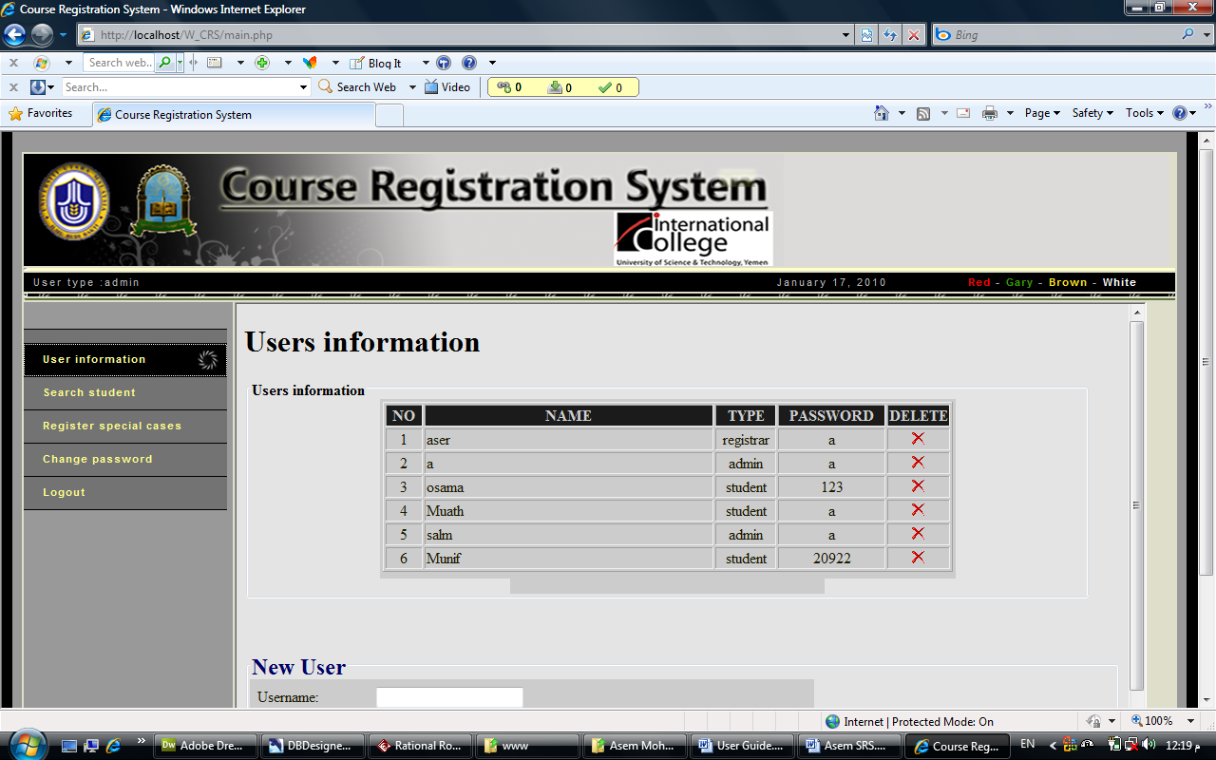
Figure 7: Main interface

- At any time you can logout of the system by pressing on the <Log out> button, at the bottom side of every page.

- Set Course Registration Period

- Press <Course Registration Period> button.
- Enter the adding/dropping period "From" and "To" dates, withdraw "To" date and the semester type as well as the semester year.
- Press <Submit> Button.
- You can also list all the history of a course registration period by press on <List> button, the history will appear down the course registration period form.

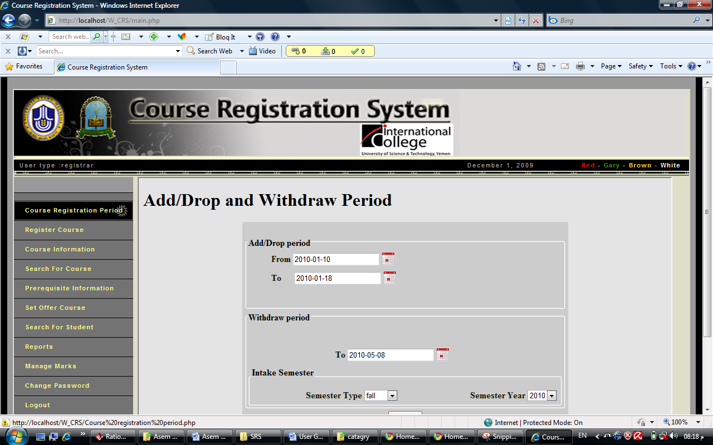
Figure 8:Course registration period

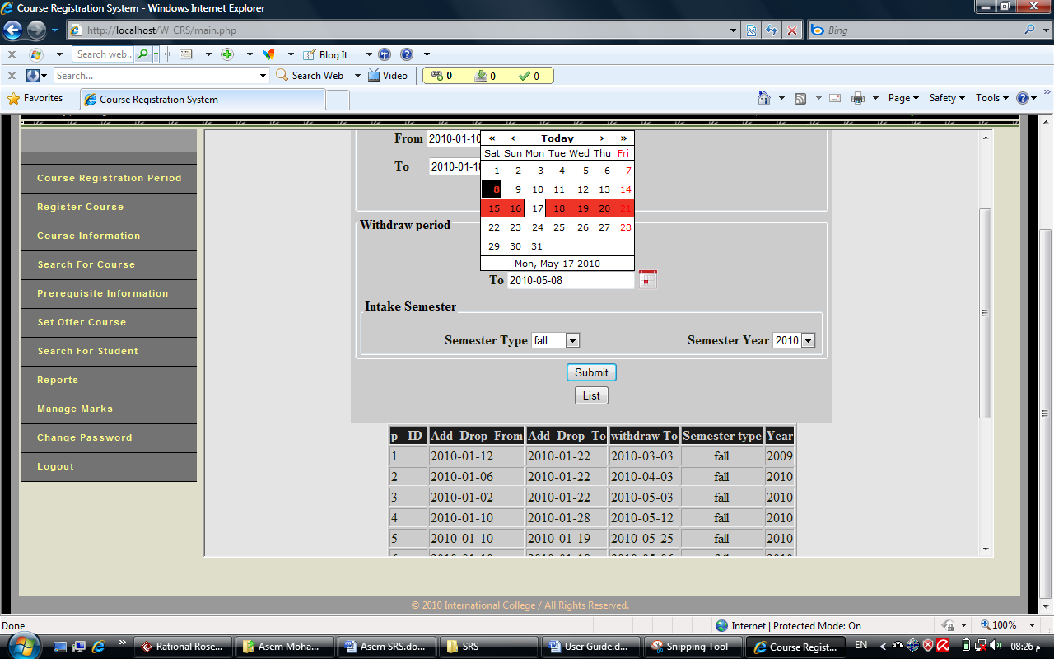

Figure 8: Course Registration setting period (2)
- Registering courses

- Press <Register Course> button.
- Select the student or search for student that he/she want to register.
- During the adding/dropping period the <Add> and <Drop> button will be active.
- During the withdraw period after the adding/dropping period the <Withdraw> button will be active.
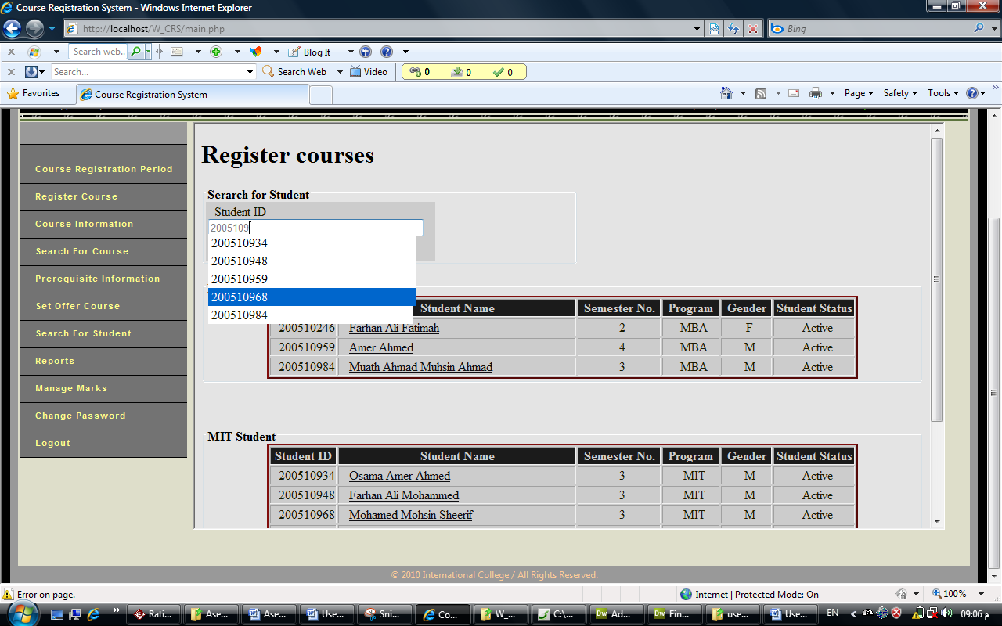

Search for student

Select student

Figure 9: Course Registration
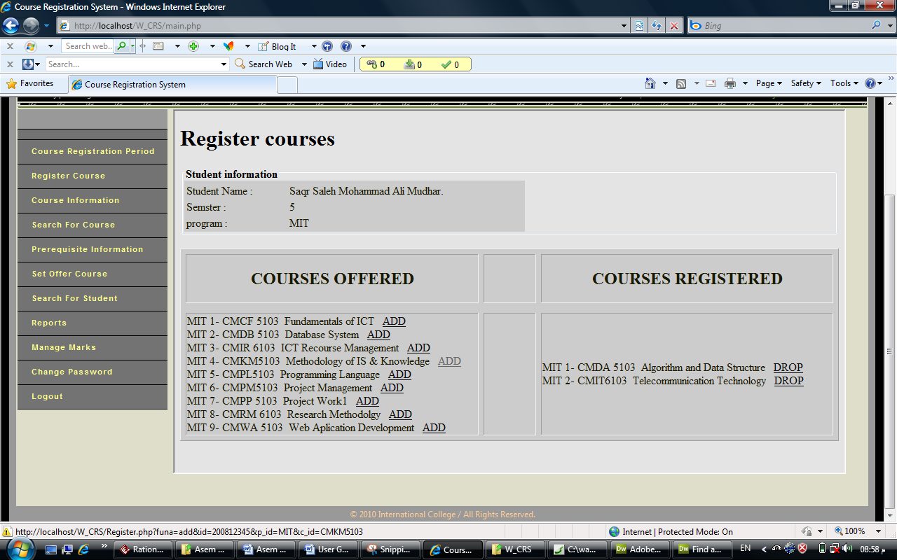

To drop course press DROP

To add course press ADD
Figure 6: Course Registration (2)
- Register Courses For Special Cases
- Press <Register Special Cases > button.
- Select the student or search for student that he/she want to register.
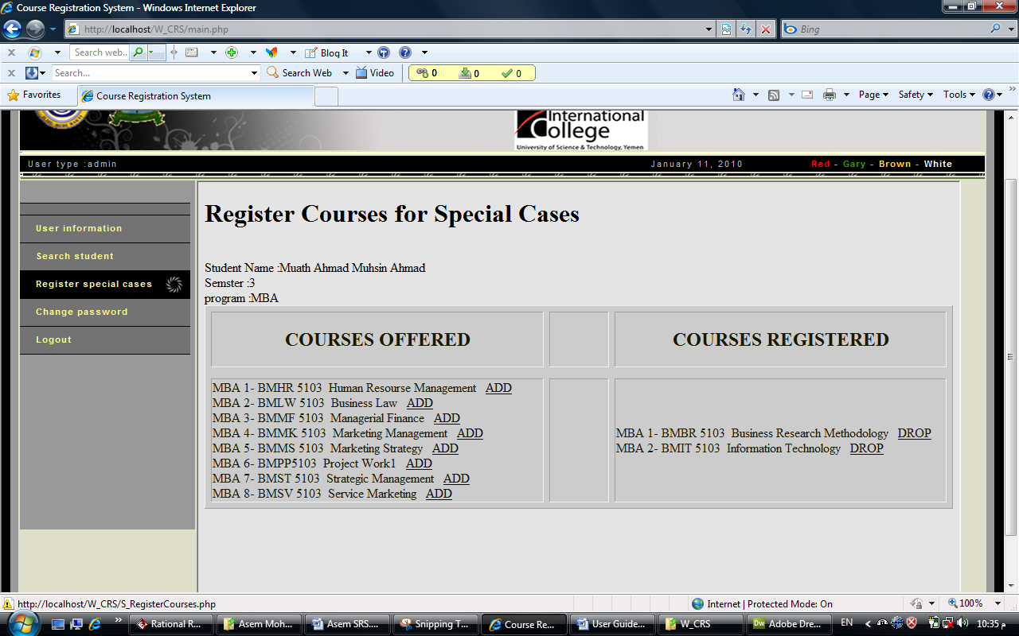
To add course press ADD
To drop course press DROP
Figure 7: Register Courses for Special Cases

- Courses information

- Press <Courses information> button.
- When you press on <Registered courses>, <Remind courses> and <Taken courses> the result will appear.

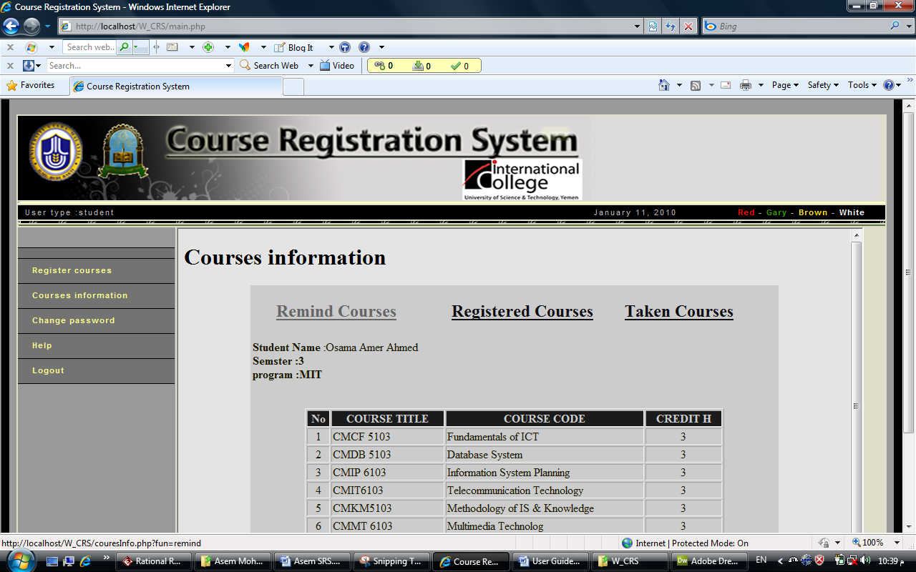
Press on the Remind course button
Press on the Registered courses button
Press on the Taken courses button
Figure 8: Courses information

- Create user

- Press < Users information > button.
- Insert the new user name, password and type of user.
- Press <Add> button.

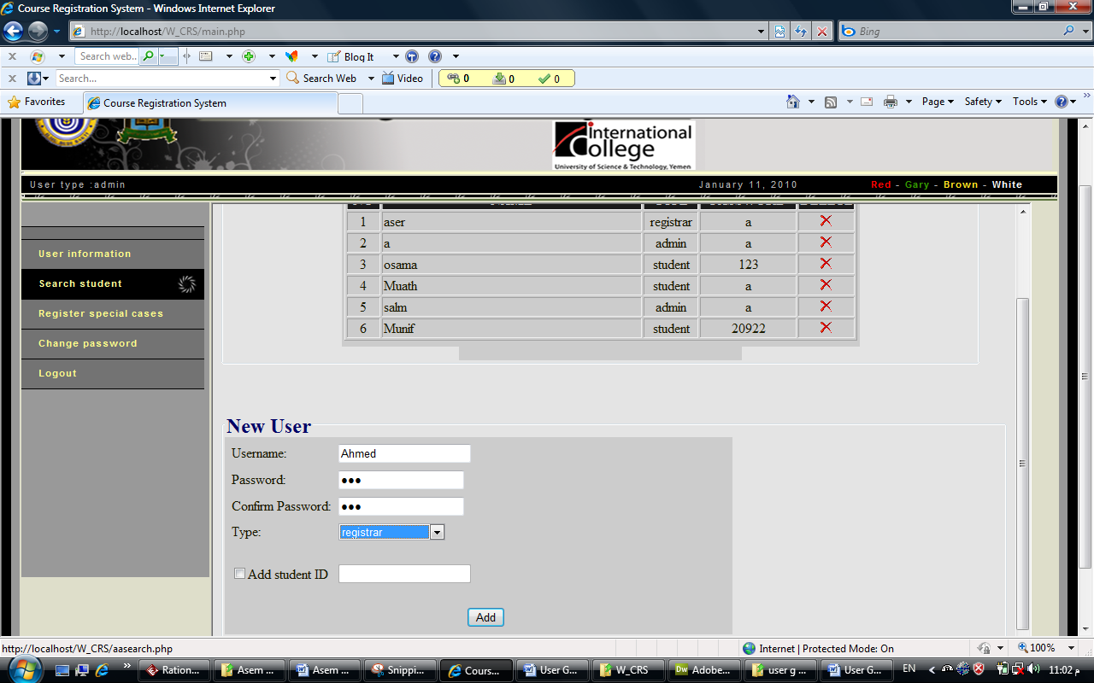
To delete user press image
Figure 9: Create user
To add course press ADD

- Search Student
- Press < Search Student > button.
- Insert student information (student ID OR student name).
- Press <Search> button.

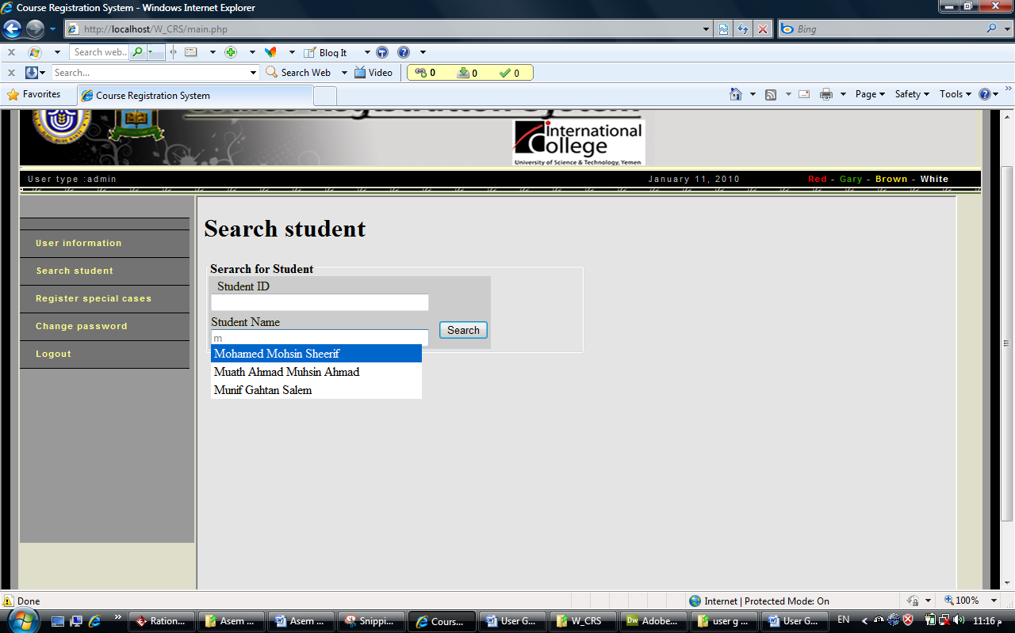
Search by student ID
Search by student name
Press <Search> button

Figure 10: Student search

- Change password
- Press < Change password > button.
- The user enters the new password
- Enter confirm Password.
- Press <Reset Password> button.

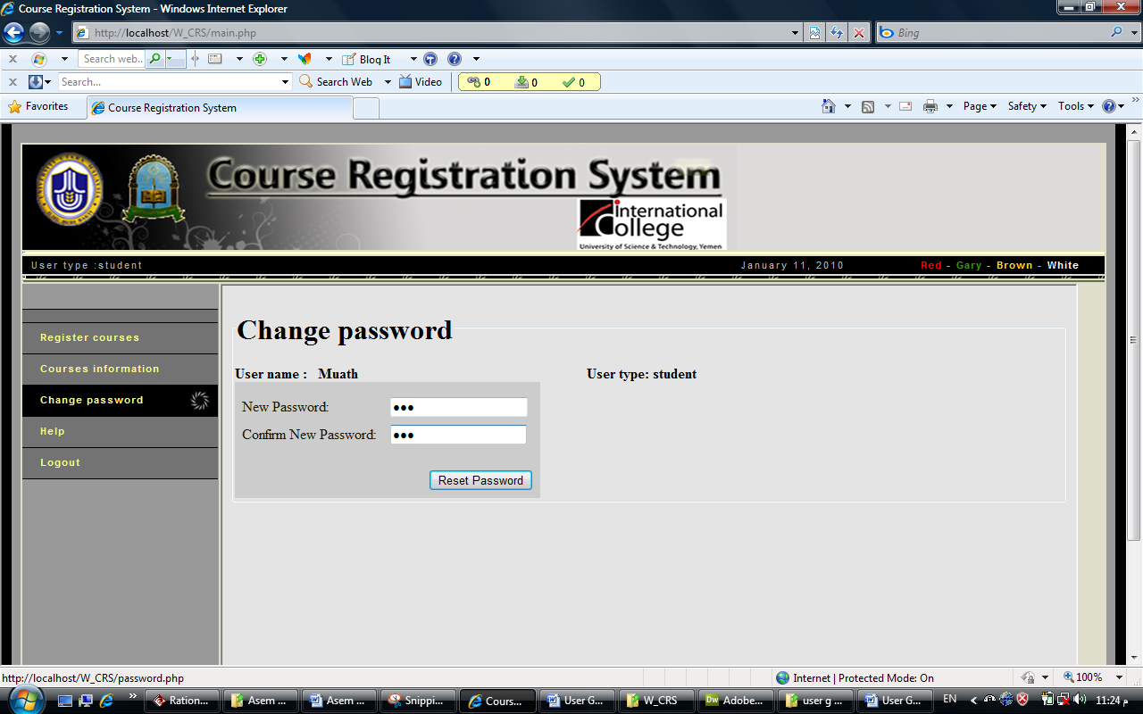
Figure 11: Change password

- Generate report

- Press <Reports > button.
- Chooses the desired report.
- Insert needed information.
- Press < Generate> button.
- The desired report page will be displayed.
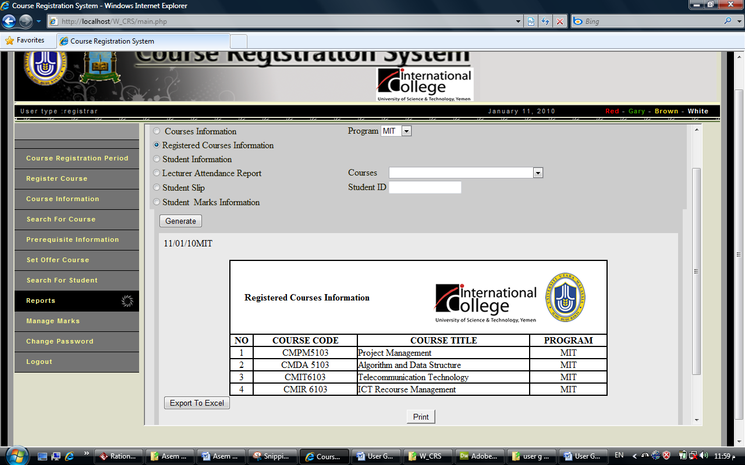
To exported to excel press <Export to Excel> button
To print out <Print> button
Press < Generate >
Chooses the desired report
Figure 12: Generate report

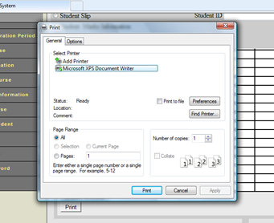
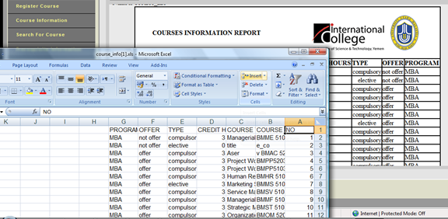
. Figure 13: Generate report(3)
. Figure 14: Generate report(2)

- Manage marks
- Press <Manage marks> button
- Select course that you want to insert the grades to students.
- Insert grades for each students and presses <Save> button.

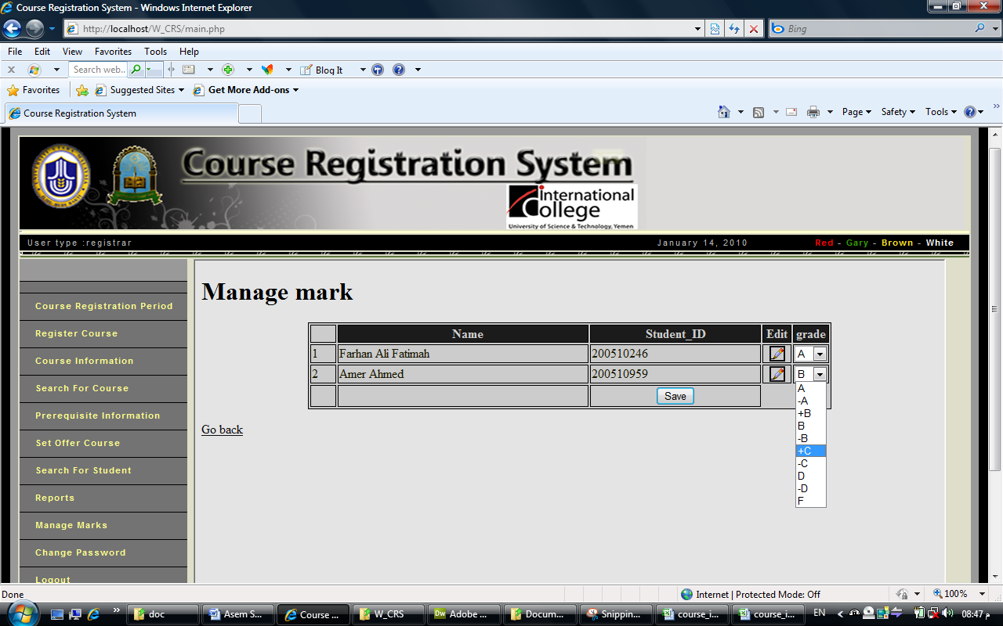
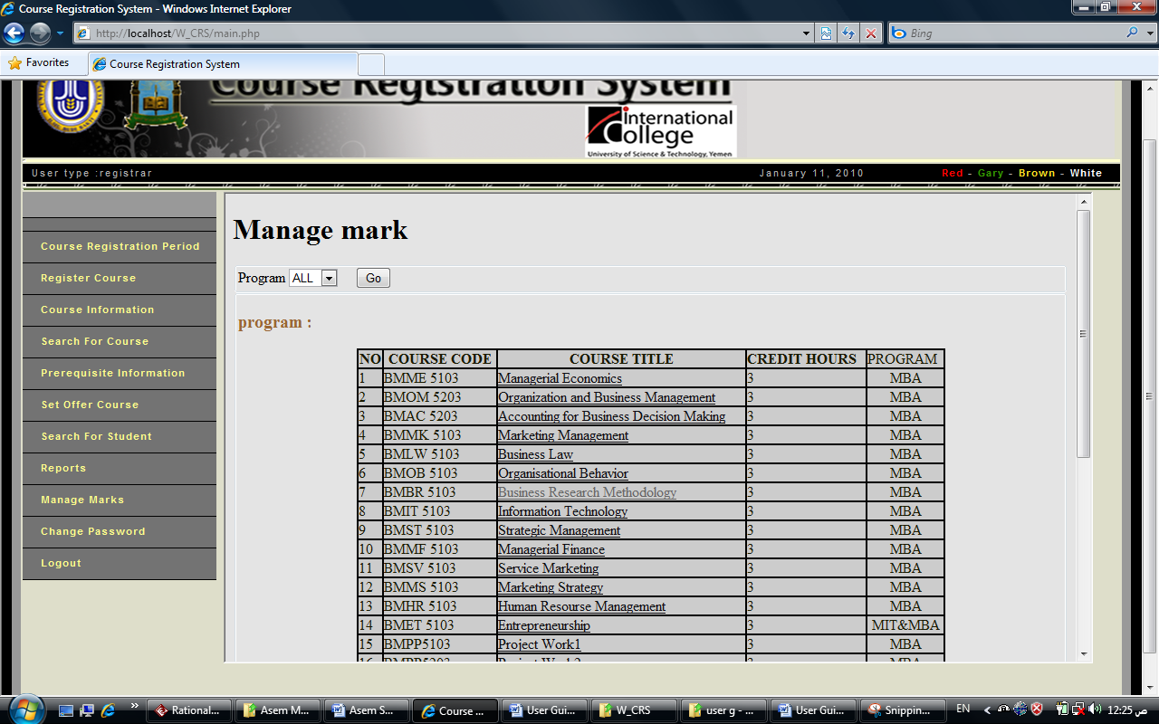
Figure 16: Manage marks(2)
Select course
Figure 15: Manage marks

Select grade

Press <Save>

- Manage Course
- Press on<Course Information> button.
- Enters course code & title &program and course information.
- Press <Add> button.
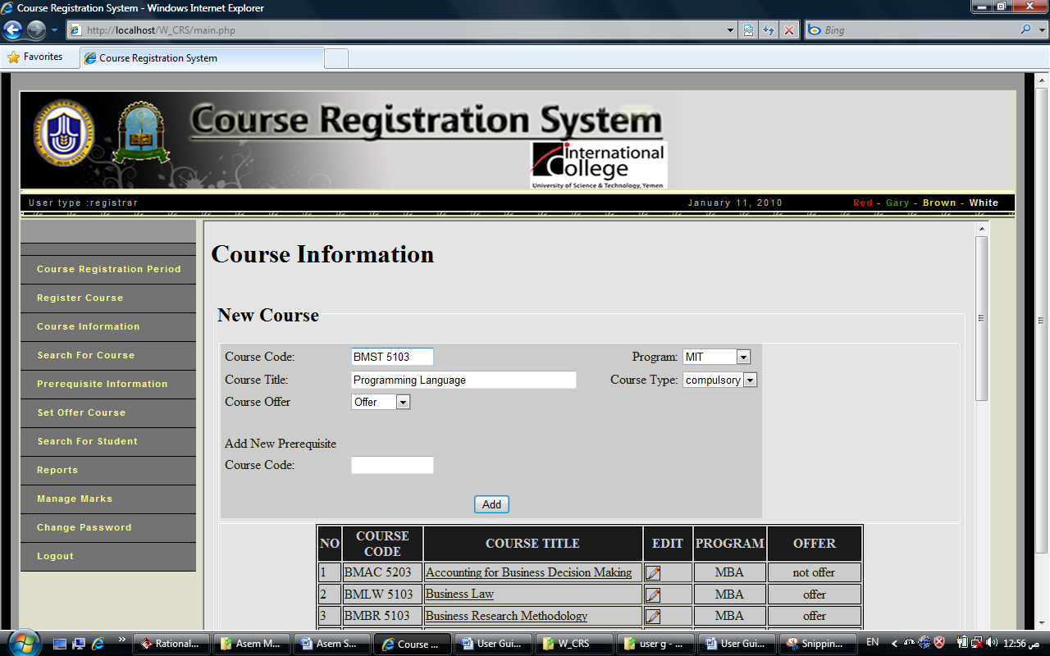
Press <Add>
To edit select course title
Press <Update>
Figure 17: Manage Course
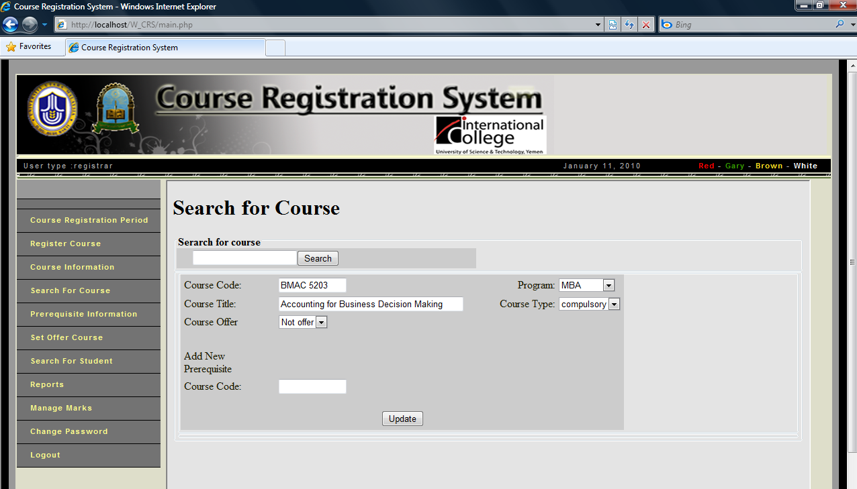
Figure 18: Manage Course(2)

Press <Save>
Search by course code

Press <Search> button

Edit course information

Add new prerequisite course

